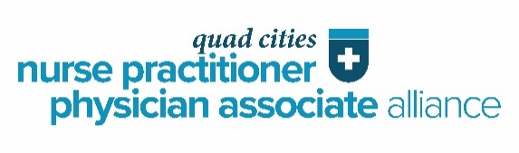
Call for Exhibitors

QC NP/PA Alliance 2026 Fall Conference
Friday, November 7th, 10:30am-5pm

Mercy One Genesis Medical Center
East Campus, Adler Health Education Center, Davenport, IA

The Quad Cities Nurse Practitioner/Physician Associate Alliance is a local nonprofit organization representing more than 150 advanced practice clinicians, including physicians, nurse practitioners, nurse midwives, clinical nurse specialists, and physician associates. Members of the Alliance provide direct patient care to individuals throughout the community.
This conference will provide an educational experience that enhances participants’ knowledge, skills, and clinical strategies, enabling them to deliver high-quality patient care. The target audience includes physician associates, nurse practitioners, pharmacists, allied health professionals, and students from health professions programs in the Quad Cities region.
The Alliance invites you to participate as an exhibitor at this conference. Each exhibitor will be provided with one table and two chairs. To reserve a display table, please complete the attached reservation form and return with payment to the Quad Cities Nurse Practitioner/Physician Associate Alliance by October 31, 2026. The cost for a display table is $1,000.00.
If your organization has questions about having a display table, please contact:
Pamela ViPond, ARNP @ psvipond@gmail.com/309.781.1426
. . . . . . . . . . . . . . . . . . . . . . . . . . . . . . . . . . . . . . . . . . . . . . . . . . . . . . . . . . . . . . . . . . . . . .
Quad Cities Nurse Practitioner/Physician Associate Alliance
P.O. Box 45, Bettendorf, IA 52722

DISPLAY TABLE RESERVATION

QC NP/PA Alliance 2026 Fall Conference
Friday, November 6, 2026

Vendor Registration and Table Set-Up: 10am
Participant Registration/Vendors Visit: 10:30am to 11:30am
Lunch with sponsored speaker 11:30am

MercyOne Genesis Medical Center-East Campus
Adler Health Education Center
1236 East Rusholme Street
Davenport, IA 52803

Target Audience: All Physician Associates, Nurse Practitioners, Pharmacists, Allied Health Professionals and students of health professions.

Company/Business: _______________________________________________________
Representative/Contact Person: _____________________________________________
Drug/Product/Service: ________________________________________
Address: ___________________________________________________
Phone: ___________________________________________________
Email Address: ______________________________________________
$1,000.00 FOR DISPLAY TABLE
____ Payment is enclosed
____ Payment will be forwarded by October 31, 2026
We look forward to your participation. Thank you!
Please direct questions to Pamela ViPond, ARNP (psvipond@gmail.com/309.781.1426.

Send completed form by October 31, 2026
Please make check payable to:
Quad Cities Nurse Practitioner/Physician Associate Alliance
PO Box 45, Bettendorf, IA 52722

